To begin the ESAP-Calibrate procedure, launch the ESAP-Calibrate program from the ESAP235.exe home screen. You will be directed to the ESAP-Calibrate start screen:

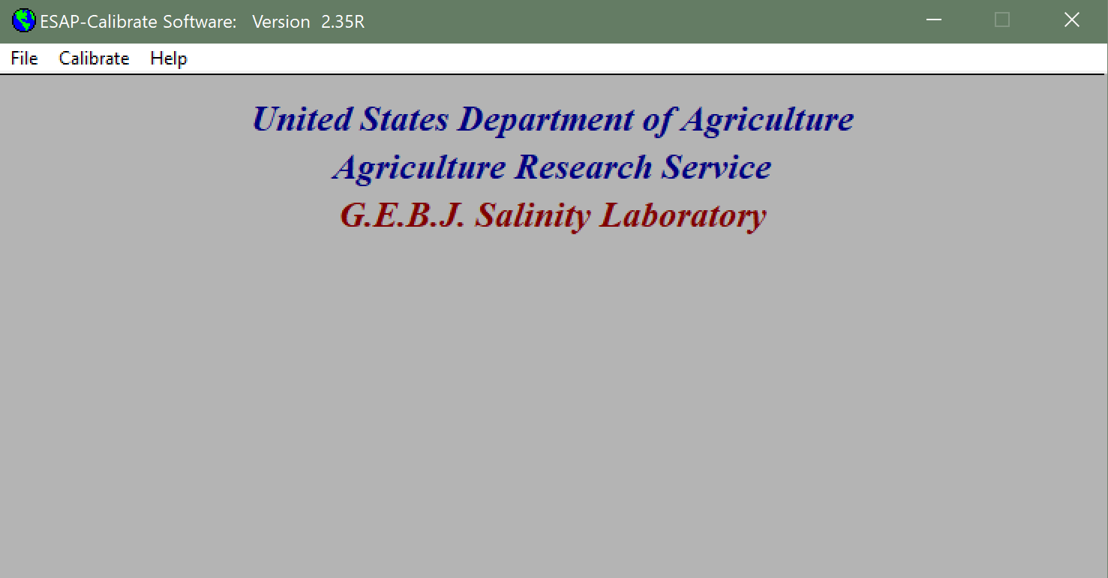

The first step is to import a survey (.svy) file generated from a previously generated by ESAP-RSSD. To do this, under the “file” tab select, “Import data file”, then, “Import Survey Data file”. The following screen will open:

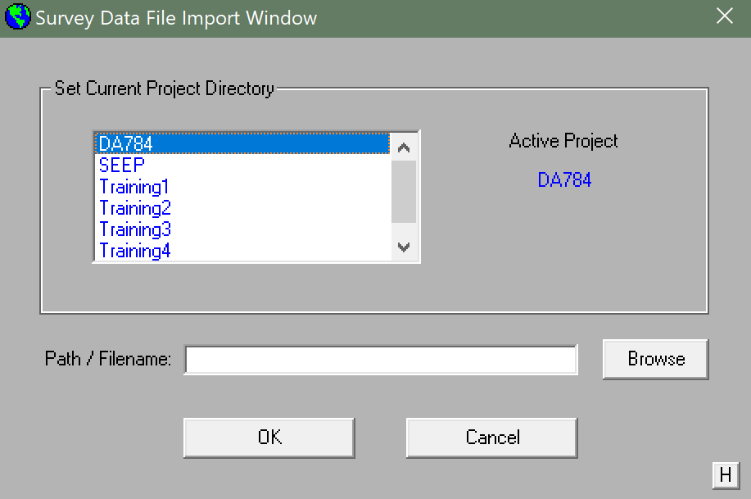

This is where you will select your project file folder with the .svy file from ESAP-RSSD. Once completed, it will take you back to the home screen.

The next step is to create a profile data file. This is done by going to “File”, “Import Data File”, and “Import Profile Data File”. This window will appear:

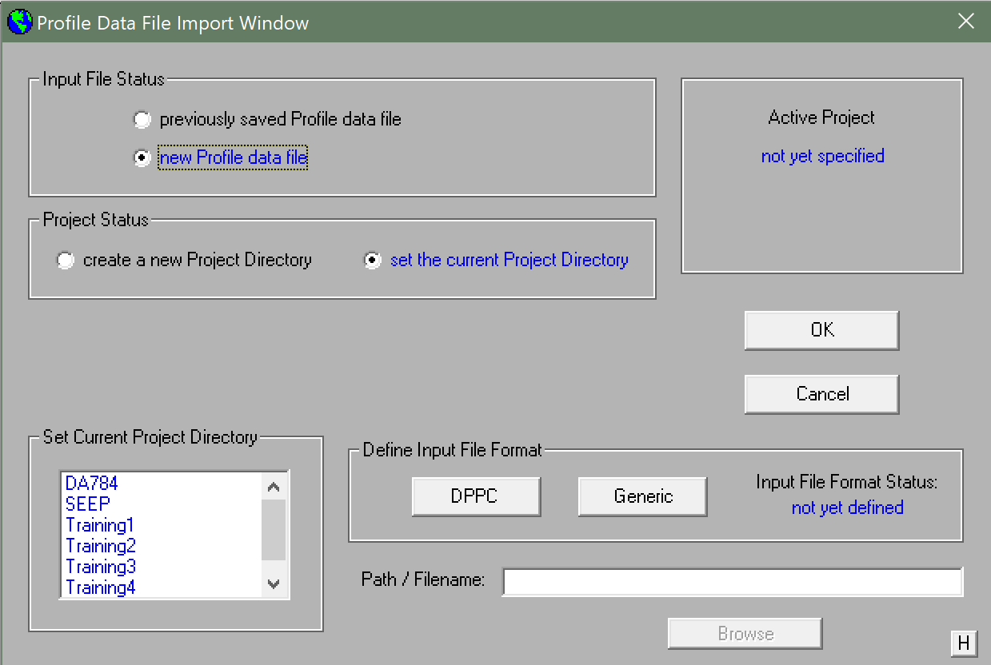

Select, “new Profile data file” and then select the type of input file format to be imported (either DPPC or Generic). For more information on the file format types, see the ESAP manual. In this example, a generic input file was used, which included data shown in the popup window for the generic file as shown below:

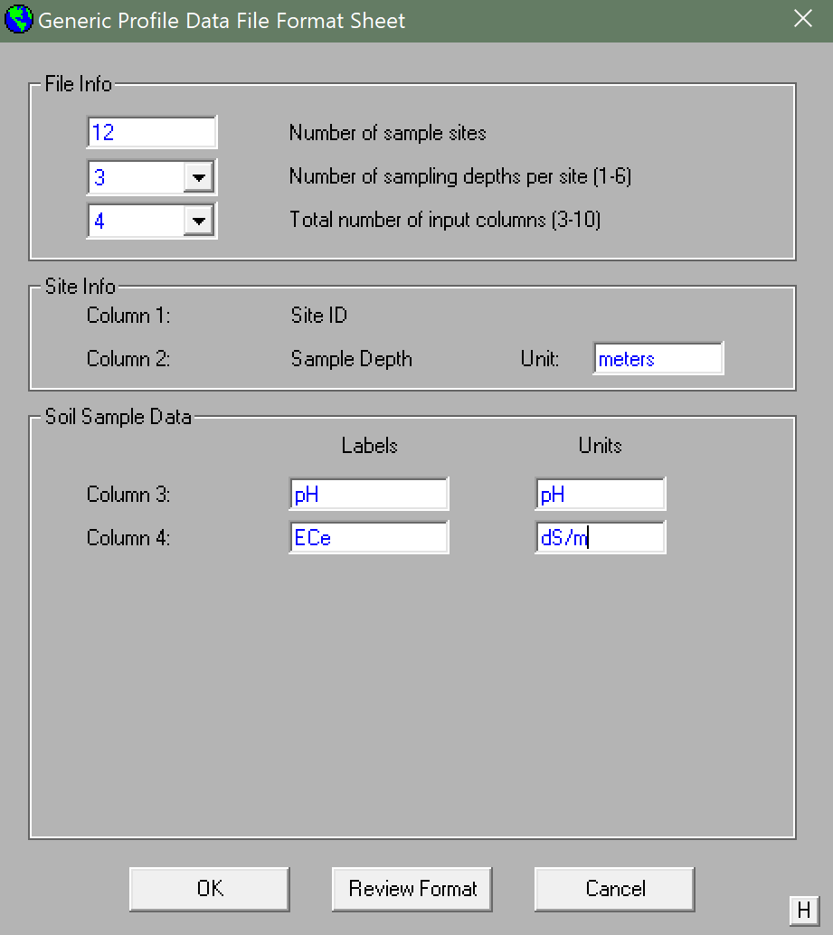

Press “OK” and then upload your file and accept it.

\*\*\*\*\*\*\*\*\*\*“Overload” error potentially occurring here. Unknown Cause\*\*\*\*\*\*\*\*\*\*

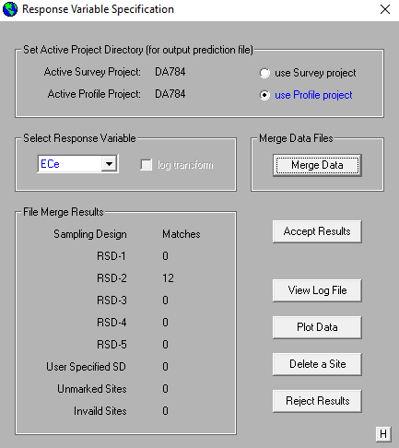

After pressing “Accept Results”, the window will close, so re-open the Stochastic calibration window.

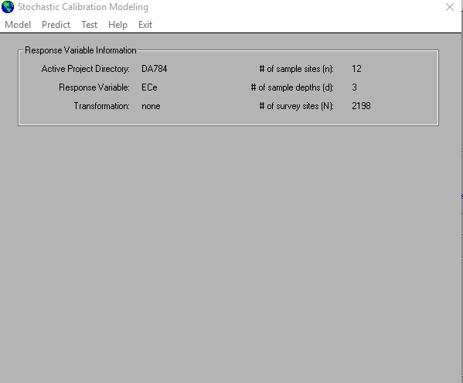

Under “Model”, select “Identify model parameters” and this should pop up. Here you may manually select a model to represent your correlation of signal data to ECe, or you may let ESAP automatically select a model based on PRESS score (a “leave one out” method for goodness of fit).

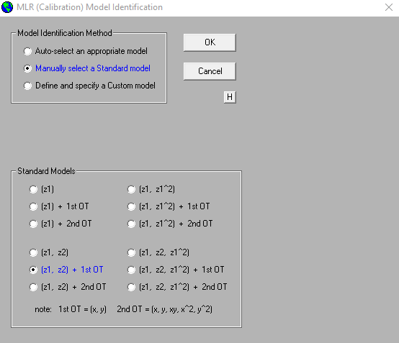

Normally, the Auto-selection method is preferred unless special conditions exist where you want and exact model. Under the “auto-select an appropriate model” button, select “Analyze all possible models” and click the “Invoke Auto-Selection Algorithm”. This will be the result:

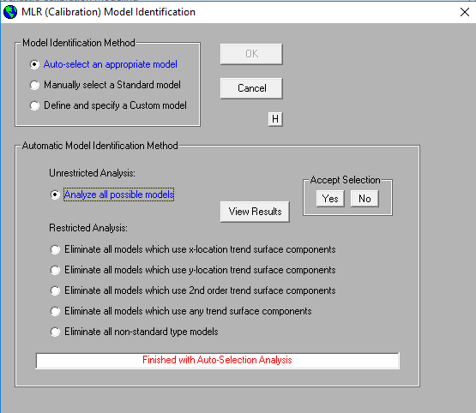

You may choose to view the PRESS rankings by clicking “View Results” after the algorithm has ran. Click “Yes” to accept the equation selection. The Stochastic Calibration Modelling screen will now have updated to include the chosen model:

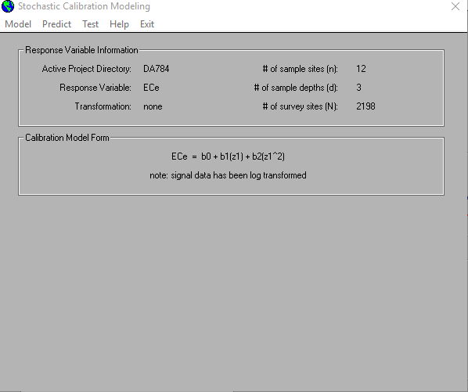

Under “Model” select “Estimate calibration equation” and be sure to check the boxes allowing for estimation of bulk average ECe values, and the calculation of Moran Residual Spatial Autocorrelation (MRSA) test statistics. The screen looks like this:

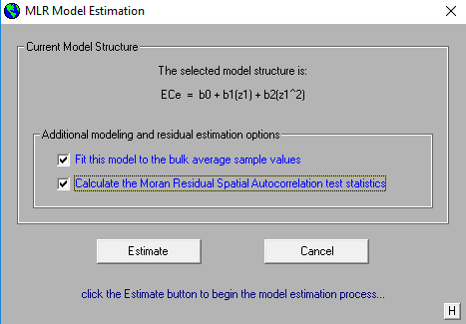

After clicking “Estimate” the Stochastic Calibration Modelling screen will have updated again to include modelling results and look like this:

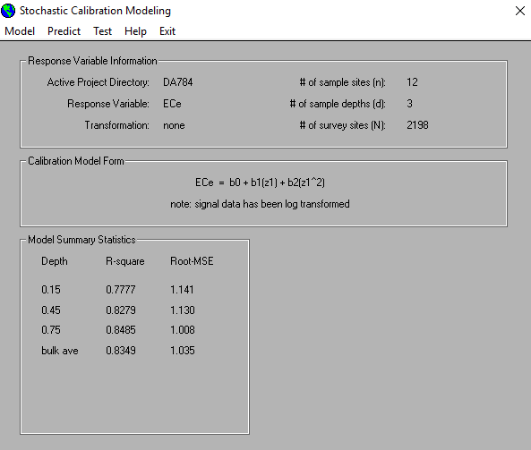

After this, you may want to save model summary and residual statistics, and residual plots by selecting “Model” and choosing “Advanced modelling options. An example window is shown below:

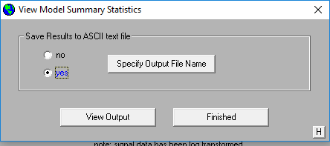

You will now see that ESAP has updated the Stochastic Calibration Modelling screen again to show you the remaining steps to complete the calibration process:

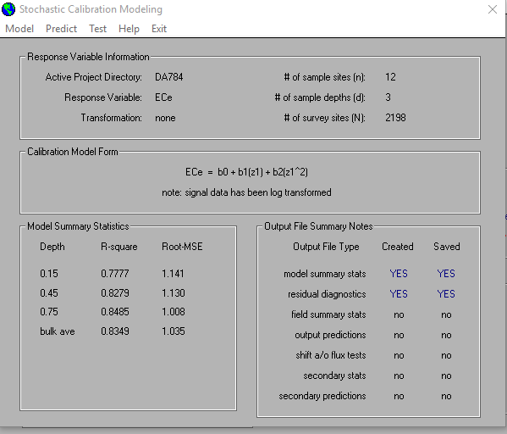

Under “Predict”, you may choose to view your data in the graphics component by selecting “View Prediction plots”. This is useful to check a 1:1 graph of observed v. predicted values. An example is shown below:

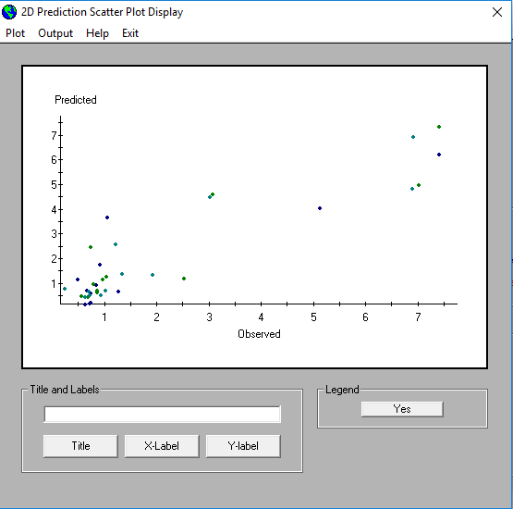

Under “Predict” select “Calculate field summary statistics”. Choose the desired variable that you want summarized (usually ECe) and specify your units, and cut-off levels as desired. When finished press, “Calculate Statistics” Then view and save the generated data into the desire location. Then click the “Finished” button, which will show up after the data has been saved.

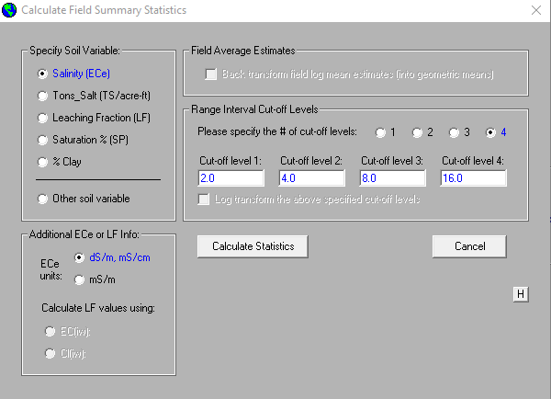

The window will close and then the Stochastic Calibration Modelling window will update showing that we have calculated field summary stats and output predictions, but have not saved any output predictions. To do so, under “Predict” select “Manipulate prediction data” and choose “Save output predictions”. This screen will show up:

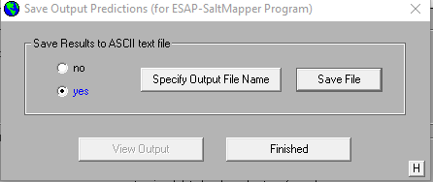

Select the appropriate location and save the .prd file.

You may now import the predictions file into excel. This file contains and ECe prediction at every soil depth and location where and EM38 reading was taken. This is an extremely useful file to have. The remaining steps in the ESAP-Calibrate model are diagnostics and auxiliary data that is more of a luxury for the user at this point. We will continue with these functions as well.

The user may be interested in looking at predicted yield loss. To do so, at the the Stochastic Calibration Modelling window, select “Predict”, then “Manipulate prediction data”, and finally “Convert predictions (ECe into Yield Loss)”. This window shows up:

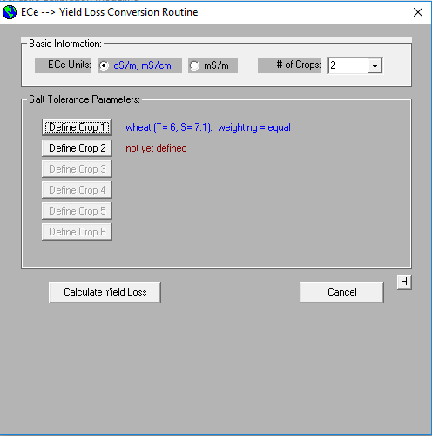

Select the number of crops you want to model, and then click the “Define Crop” button to select the type. It can do custom crops so long as the user can specify the ECe threshold and slope of the plant. This window is shown below:

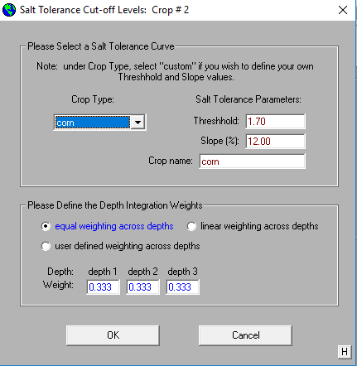

You may then choose to view and save the resulting summary statistics and site-specific yield predictions form the yield loss conversion routine window. After saving, click “Done”. The Stochastic Calibration Modelling window is now nearly satisfied with the analysis, with only “shift a/o tests” to be created and saved. The Stochastic Calibration Modelling window should look like this:

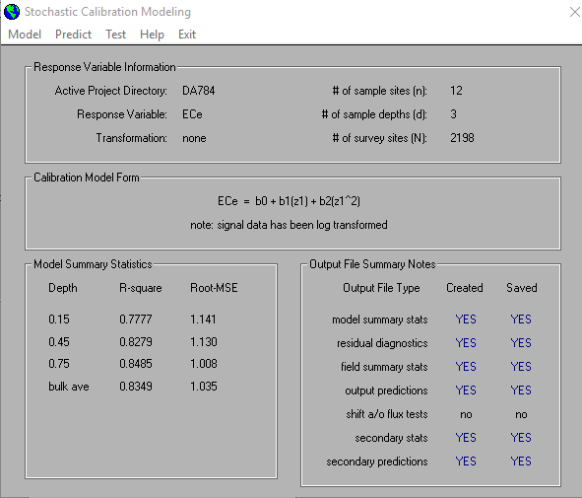

The calibration is now complete, regardless of the mean-shift testing process. The Mean-shift Testing window can be used to request mean-shift tests for any field that has been surveyed and soil sampled twice. If you acquire additional survey data in the future (along with a new set of soil samples), you can generally use this new information to statistically determine if the average magnitude of the predicted soil variable has changed over time. These "mean-shift" tests perform an approximate comparison of the two predicted field means (for each sample depth), using a 2-sample t-test procedure.

Since in this example, there is only one EM38 Survey on this field, a mean shift test example is not included in this document.

The other test is a net-flux test. The Net Flux window can be used to import and test for changes in the levels of soil sample data collected across your survey area, if you collect additional sample data at one or more calibration sites in the future.

For example, suppose you perform an electromagnetic survey on a salt affected field, select 12 survey locations for soil sampling, and then use the ESAP-Calibrate program to generate predicted salinity data. After examining the predicted salinity map, the farmer decides to leach the field by applying 2 acre feet of irrigation water for a 30 day period. After 30 days (i.e., after the leaching process), you re-enter this field, re-sample the 12 calibration sites (acquiring 12 new soil cores), and determine the new soil salinity levels at these 12 sites. Then, by using the options in the Net Flux window, you can enter this data into the ESAP-Calibrate program and test if the salinity pattern has changed, and if so by how much.

Since in this example, only one set of soil sample were collected, a net flux test example is not included in this document.

The ESAP-Calibrate process is now complete! The program will then return to the window titled, “ESAP-Calibrate Software: Version 2.35R”